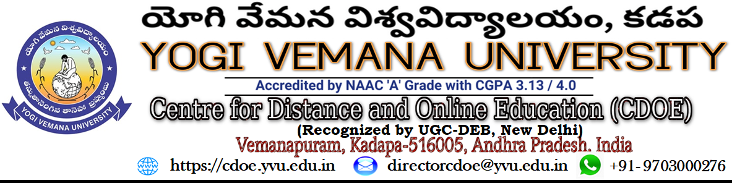

personal contact progammes (PCP)

Dear Students , Dec.2023

Greetings from Yogi Vemana University - Centre for Distance and Online Education (CDOE) Learning! CDOE is organizing Personal Contact Program (PCP) classes for all students enrolled in the following 8 Postgraduate programs:
8-POST- GRADUATE PROGRAMME
MA - History | MA-English
MA - Economics | MA- Mass Communications & Journalism
MA- Political Science | M.Com- General
MA-Telugu | MA-Psychology
The PCPs have been designed to facilitate tutor-student interaction and aim to provide students with an overview of the program's structure and concepts taught in a blended (physical and online) mode. We strongly advise you to attend the program in physical mode and recommend the same to your peers who have enrolled in the program at CDOE.
Schedule for PCP contact Classes:
Sl.No. | Month | Dates | No. of Days
1 | January 2024 | 7,13,21,26 and 28 | 05
2 | February 2024 | 4,10,11,18 and 25 | 05
3 | March 2024 | 03, 8,9,and 10 | 04

We eagerly anticipate the opportunity to meet with you in person or through online platforms and engage in meaningful interactions during the upcoming Personal Contact Program. Should you have any inquiries regarding the PCP, please feel free to reach out via email at directorcdoe@yvu.edu.in.
With warm regards,
Prof. K.Krishna Reddy
Director

